**Prepare for Assembly Test**

**Module Description**

During this module, the participants will select appropriate scenarios to test the amended code. The participants will create new assembly test scripts or update existing ones, as required.

For assembly readiness testing, the participants will integrate the code and execute the scripts. On completion, the participants will check that all the deliverables they created are checked in and correct.

**Participant Presentation**

Click the link to launch the [Module 46 Presentation](https://accenture.desire2learn.com/content/enforced/9406-Pending/W4_Participant_Materials/Module_46/ADF_2_0_Java_Module46_TimeWarp_PD.pptx?_&d2lSessionVal=YnoL4daZGC8ne2RyGf0cWMrk8).

**Scenario**

The Test Team has added the TCERs required to support the requirements changes to the Assembly and Product Test TCERs documents.

You and your teammates will check the Test Scenarios and TCERs. You will then add some of the new Test Scenarios and TCERs to the TCER document and to the TCCS for the Assembly Readiness Test as directed by the Test Approach document.

You will then update the assembly readiness test JUnits created in Release 1 and execute them on the new code. If defects exist, the defect fix must be repeated in the development environment and then fixed, unit tested and redeployed.

As a major milestone deadline draws closer, it's a good time to have a status meeting. The Team Lead will let the team know when the meeting will occur. You are responsible for preparing your status! Your team will report status to the Project Manager.

**ADM Activity Context Diagram**

Application > 4100 Build Application > 4193 Start Assembly Test Fix Support to Verify Readiness

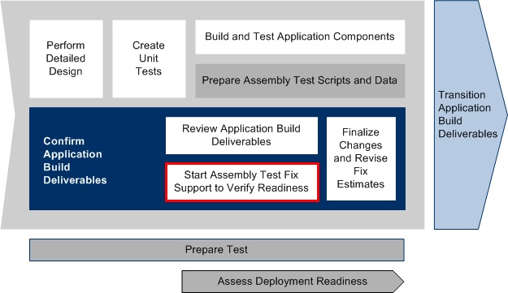

Test Application > 4700 Prepare Test > 4793 Start Assembly Test to Verify Readiness

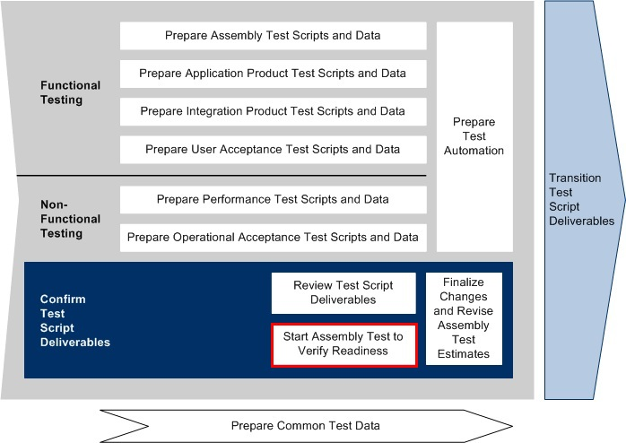

**Roles**

|  |  |  |  |
| --- | --- | --- | --- |
| **Role** | **ADM Task** | **ADM Responsibility** | **Description** |
| Team (All) | 4193 Start Assembly Test Fix Support to Verify Readiness  4793 Start Assembly Test to Verify Readiness | Primary Performer | Updates the TCCS and Test Scenarios/TCERs documents to support testing the defect fixes and the Change Request enhancements to the code. |
| Developer | Team Status Meeting | Primary Performer | Provides status on assigned tasks and activities including what is completed, in-progress, or delayed.  Communicates any issues that impact progress or productivity. |
| Team Lead | Team Status Meeting | Primary Performer | Leads the Status meeting and compiles feedback.  Addresses and corrects any issues where possible. Escalates issues when appropriate. |
| Project Manager | Team Status Meeting | Management Oversight | Provides guidance on the Team Status Report (if needed).  Handles any escalated issues from the Team Leads. |

**Participant Instructions**

(NOTE: This is typically done by testers, but as previously mentioned, for smaller projects and projects behind schedule, developer teams can do this.)

1. Open the following work products:

a. [TE584 Assembly Test Conditions and Expected Results (Release 2)](https://accenture.desire2learn.com/content/enforced/9406-Pending/NCCC_Project_Work_Products/3d_App_Test/Assm_TestCond_FERS_R2_REF.xlsx?_&d2lSessionVal=YnoL4daZGC8ne2RyGf0cWMrk8)

b. [TE583 Assembly Readiness Test Scenarios (Release 2)](https://accenture.desire2learn.com/content/enforced/9406-Pending/NCCC_Project_Work_Products/3d_App_Test/Assm_TestScen_FERS_R2_REF.xlsx?_&d2lSessionVal=YnoL4daZGC8ne2RyGf0cWMrk8)

2. Open your test documentation from Release 1 and save it under a new filename for Release 2 (as described above):

a. TE584 Assembly Readiness Test Conditions and Expected Results (Release 1)

b. TE583 Assembly Readiness Test Scenarios (Release 1)

3. Review the Release 2 Assembly Test Scenarios and TCERs and **add only** Assembly Test Scenarios/TCERs to your Release 2 TE583 Assembly Readiness Test Scenarios that are important to verify the readiness of the application for assembly test.

4. One pass of assembly test will be done by assembling all of the coded classes together (testing the assembly of the controller code to the database level).

5. The Team Lead (with help of Team) will create / review the Assembly Readiness Test Cycle Control Sheet (TCCS) Release 2 based on the following:

a. [TE585 Assembly Readiness Test Cycle Control Sheet (Release 2)](https://accenture.desire2learn.com/content/enforced/9406-Pending/NCCC_Project_Work_Products/3d_App_Test/Assm_TestCycle_FERS_R2_REF.xlsx?_&d2lSessionVal=YnoL4daZGC8ne2RyGf0cWMrk8)

b. [TE585 Assembly Readiness Test Cycle Control Sheet (Release 1)](https://accenture.desire2learn.com/content/enforced/9406-Pending/NCCC_Project_Work_Products/3d_App_Test/Assm_TestCycle_FERS_R1_REF.xlsx?_&d2lSessionVal=YnoL4daZGC8ne2RyGf0cWMrk8)

6. As a team:

a. Determine what TCER outputs should be expected at this level of assembled application code.

b. Make updates if needed to TCERs output to account for the test data set being used.

c. Create Assembly Readiness Test JUnit classes for testing by leveraging the TE586 Assembly Readiness Test Script - JUnit Code.

7. Run the team’s updated assembly readiness test scripts (J-Units) as defined in the Assembly Readiness TCCS.

8. Correct your application code if needed based on the results of the test execution.

**Hints and Tips**

1. Be careful when changing/using your test data values in your TCERs!

2. The TCERs to be identified will effectively test the sending of messages (i.e., method calls) from class to class across layers of the Web Application code.

3. The TCCS will list the order in which the test scripts will be executed and reflect the order groups of classes/components will be introduced into the test environment.